1. Count and Write the correct number of objects

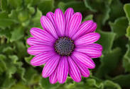  

1. 5 b) 3 c) 1 d) 6

2 Count and write the correct number of objects

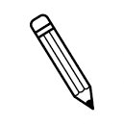   

1. 8 b) 11 c) 5 d) 4

3 Count and write the correct number of objects

a)1 b­) 9 c) 6 d) 2

4. Choose the number that comes between 9_____11

a) 11 b) 15 c) 6 d) 10

5. Choose the number that comes after 10______

a) 6 b) 16 c) 11 d) 9

6. Choose the number that comes before ___6

a) 6 b) 5 c) 0 d) 8

7 Put the correct symbol 5 ____ 5

1. < B) > c) = d) none of these

8. Write the number name of 11

a) Six b) two c) nine d) eleven

9. Complete the missing number

a) 1 ,2, ___, 4,____, 6, ____ ,8 ,_____, 10.

b) 11, 12, ___, ___, ___, 16, 17 ,18, 19 , _____.

C ) 1, 2, 3, ____, _____, _____, 7,_____, 9, 10.

10 . Put the sign >,<.or = .

(a) 18 ____ 8

(b) 6 -_____ 12

(c) 7 _____ 10

11. Circle the greatest number

(a) 16 , 3 , 8, 19

(b) 5, 18, 10, 8

(c) 12, 19, 4, 17